Kidspoem/Bairnsang

By Liz Lochhead

C:\Users\gbb14102\AppData\Local\Microsoft\Windows\Temporary Internet Files\Content.IE5\H89G43WL\MC900363604[1].wmfit wis January   
and a gey driech day   
the first day Ah went to the school   
so my Mum happed me up in ma   
good navy-blue napp coat wi the rid tartan hood   
birled a scarf aroon ma neck   
pu'ed oan ma pixie an' my pawkies   
it wis that bitter   
said noo ye'll no starve   
gie'd me a wee kiss and a kid-oan skelp oan the bum   
and sent me aff across the playground   
tae the place Ah'd learn to say 

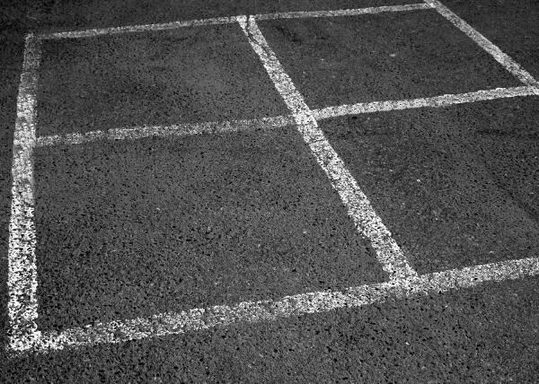it was January   
and a ____________ dismal day   
the first day ___________ went to school   
so my mother wrapped me up in my   
best navy-blue top coat with the ____________ tartan hood,   
______________ a scarf around my neck,   
pulled on my bobble-hat and ____________  
it was so bitterly cold   
said ___________ you won't freeze to death   
gave me a little kiss and a pretend ____________ on the bottom   
and sent me off across the playground   
to the place I’d learn to forget to say 

it wis January   
and a gey driech day   
the first day Ah went to the school   
so my Mum happed me up in ma   
good navy-blue napp coat wi the rid tartan hood,   
birled a scarf aroon ma neck,   
pu'ed oan ma pixie an' ma pawkies   
it wis that bitter.

  
Oh saying it was one thing   
but when it came to writing it   
in black and white   
the way it had to be said   
was as if you were posh, grown-up, male, English and dead.